Modern Language Association Documentation- MLA Update 8th Edition 2016

**MLA Style consists of 3 areas of formatting: Spacing, Citations, Works Consulted/Cited

- Spacing-MLA style requires Double Spacing throughout every document, 12 point font and 1 inch margins.

- Heading-Goes at the upper left corner of the first page in this order:
Student Name Bobby Smith
Teacher Name Mrs. Hunt
Class name-hour ELA-9 3rd Hour
Date with number first 5 May 2010
- Page Numbering-insert a page number at the top right corner and type your last name in front of it with a space.

- Long Quote Spacing-if a quote is 4 lines or longer, tab the entire quote 2 times. Put the citation after the period (see sample below) and do not put quotation marks (because it’s indented twice, it is assumed it is a long quote).
______________________________________________________________________________________
Jones 1
Courtney Jones
Mrs. Hunt
ELA 9--5th hour
2 November 2016
Mahatma
One of the most famous nonviolent activist, who rested his confidence in God not as a person but as a force, Gandhi, especially like to call love not love but truth. He wrote of that force in 1925 (Alles). Mohandas Gandhi had a common Indian childhood, he had a starting career as a lawyer, he led a struggle for Indian Independence, and he had a philosophy of Satyagraha.
I do dimly perceive that whilst everything around me is ever-changing, ever-dying, there is underlying all that change a Living Power that is changeless, that holds all together, that creates, dissolves, and re-creates…I see it as purely benevolent. For I can see that in the midst of death life persists, in the midst of untruth truth persists, in the midst of darkness, light persist. (Alles)
“Gandhi was especially involved in the peaceful resolution of conflict and refused to condone violence in any form” (“Gandhi”).
2. Citations- you must tell where you got any information in your paper taken from another source. Use Parenthetical References or Citations (same thing) to do this. You MUST cite all facts, even if you put them in your own words. If you don’t cite your information, it is considered plagiarism. You cannot just copy and paste information from a source. You have to tell where you got it.

Basically, there are two types of information you would take from a source:
  - Direct Quote- information taken “word for word” from an outside source. Must be documented with quotation marks at the beginning and end.
  - Paraphrase/Summary- information reworded or summarized from an outside source. No quotation marks are to be used with paraphrases.

According to the MLA Handbook for Writers of Research Papers, plagiarism is: “Using another person’s ideas, information, or expressions without acknowledging the person’s work constitutes intellectual theft”(Gibaldi 66). When in doubt, CITE!!!!

**A Citation/Parenthetical Reference shows information in parenthesis to lead back to the original source listed on your Works Consulted/Cited. The parentheses are placed directly after the information taken from the source (the quote or paraphrase) before the period (see sample).

- Always put the author’s last name if there is an author. (Baker)
- If not, (many web sources don’t have authors listed), put the name of the page title. (“The River.”)
- If you have more than 1 source with the same page title, use the Source Title (Biography.com)
- If it is a printed source (a book, magazine etc that’s not online), also put the page number
(Baker 42)
- ALL CITATIONS SHOULD HAVE AN ENTRY ON THE WORKS CONSULTED/CITED PAGE!! Citations are the short identification of the source in the paper that refers to the full source identification on the Works Consulted/Cited page.

Works Consulted/Cited-double spaced like the rest of the paper, alphabetized according to the first letter of the entry (whatever it is, author or page title, ignore the words a, an or the). If you have more than 1 entry with the same page title, alphabetize by the website title. Start each entry at the margin and indent the rest of the entry (see sample on next page). You can type the entries, double space them, highlight them all, go to Format-Paragraph-Special-Hanging Indent to space it correctly.

- Works Consulted/Cited- This is a list of sources. It replaces the word “Bibliography”

- In a works consulted, you would list sources that you looked up about your topic, some of which you cited in your paper. There are sources listed here about your topic that you didn’t cite in your paper.
- In a works cited, you only list the sources you actually cited.You have parenthetical citations in your paper for ALL of the sources listed.

When deciding how to cite your source, start by consulting the list of core elements. These are the general pieces of information that MLA suggests including in each Works Cited entry. In your citation, the elements should be listed in the following order with the following punctuation:

- Author. Last name, First name.
- Title of source. in “” (example: website page title “Bobby Orr”)
- Title of container, In italics (example: NHL.com)
- Other contributors, (if any)
- Version, (if any)
- Number, (if any)
- Publisher, (look at very bottom of website)
- Publication date, (look at top or very bottom for year or full date)
- Location. (URL) Delete “http://” from URLs.
- Date accessed. example: Accessed 16 November 2016.

The full entry would look like this with the correct punctuation after each piece of information and at the end:

Zinkievich, Craig. “Interview by Gareth Von Kallenbach”. Skewed & Reviewed,27 Apr. 2009,
www.arcgames.com/en/games/star-trek-online/news/detail/1056940-skewed-%2526-reviewed-interviews-craig. Accessed 15 Mar. 2009.
________________________________________________________________________________________ Shmoe 4
Works Cited
Dean, Cornelia. "Executive on a Mission: Saving the Planet." The New York Times, 22 May 2007, www.nytimes.com/2007/05/22/science/earth/22ander.html?_r=0. Accessed 12 May 2016.
Gowdy, John. "Avoiding Self-organized Extinction: Co-evolutionary Economics of Sustainability." International Journal of Sustainable Development and World Ecology, vol. 14, no. 1, 2007, pp. 27-36.

Works Consulted/Cited for Certain Types of Sources:

Print Source: Only the most essential information is included (author’s name, book title, publisher, and date) Example: Jacobs, Alan. The Pleasures of Reading in an Age of Distraction. Oxford UP, 2011.

Interview: Name of person interviewed. Personal Interview. Date
Example: Jones, Melissa. Personal Interview. 27 Oct. 2003.

How to Cite a Website
Website – A collection of informational pages on the Internet that typically include an article title, author and publisher.
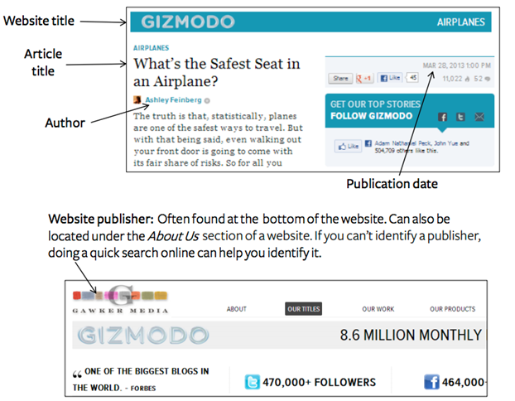

Citing a website with no author
Note: Depending on the content, credible websites do not always include authors.
Date Accessed: This is the day the article was read and found.

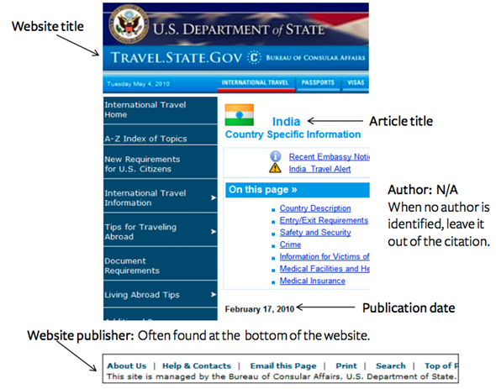

Date Accessed: This is the day that the article was found and read.
© 2001-2016 EasyBib, a Chegg service.
***For other sources, go to this website to see how to do a Works Consulted/Cited page.

https://owl.english.purdue.edu/owl/resource

